|  |  |  |
| --- | --- | --- |
| **Work Integrated Learning Laboratory**  **Week 2: Web debugging** |  | |
| Name:Atthapong Chooduang | ID:6231302022 | Section:1 |
| Date: | Due: Wednesday Midnight | |

**Objective**

* To debug JavaScript using Chrome DevTools

**References**

* <https://developers.google.com/web/tools/chrome-devtools/javascript/>
* <https://www.youtube.com/watch?v=x4q86IjJFag>

Here we will try to play with a page “reg.mfu.ac.th”.

* **How to use Chrome DevTools?**

Right click on a web and select “inspect” or CTRL+SHIFT+i

* **How to check our web page in different screen sizes?**



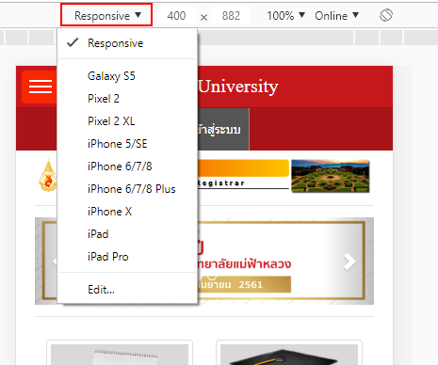

* **How to modify HTML content, adding tag’s attributes, hide elements, delete elements, and move elements?**

We will try to change the title message.



First click the arrow icon.

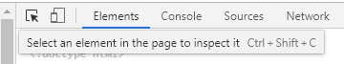

Then move the mouse over the title text and click it. The inspector shows the related HTML.



Double click the university name and try to change it.





Now we will try to swap the position of



Find the related codes.

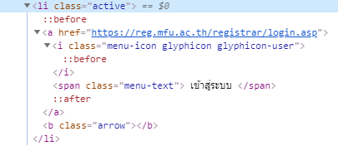

Then drag the line <span> up and drop over <i>.

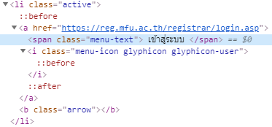

See the updated result.



Now try to delete this item by clicking at <li>

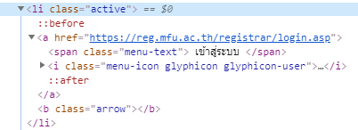

Then press “delete” button. Observe that this element disappears.

We can press “CTRL+z” to undo the delete.

Now try to hide this element by right clicking and select “hide”.

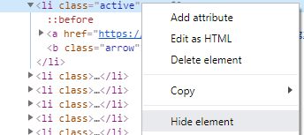

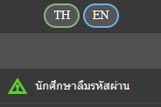

To unhide it, repeat the previous step.

Now try to select the banner. Observe that it is not clickable.



Select the related codes.



Right click at <img> and select “Add attribute”.

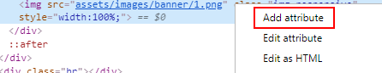

Add “onclick” as shown below.



Now you’ll see a popup while clicking at the banner.

Next let us change a picture.



Let change the left picture to the right. Select the corresponding code.

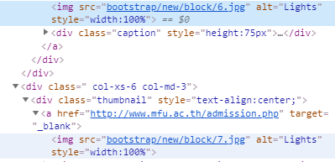

Double click the top <img> and change “6.jpg” to “7.jpg”.

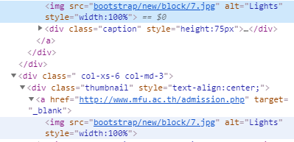

See the update.



* **Modifying CSS, changing color, picking color, add new class**

We’ll try to change the top color from “red” to “green”.





Move below and observe.

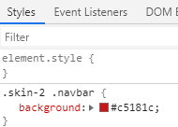

First try to disable the background color. Move the mouse over the style and uncheck it.

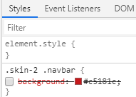



Now enable the style and change its color to #00aa00.



Click the color icon before the color code.

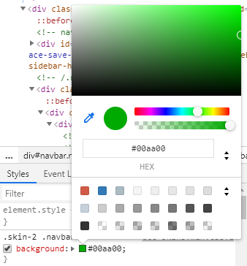

Assume that we want to pick color from the screen.

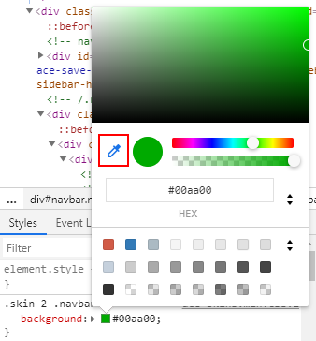

The move your mouse to pick a color you want.

Next let us change the text color.





See that the text is in <small>. Try to add its ID.



Now move downward and observe the style.

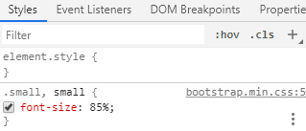

Add new style.

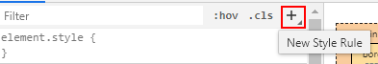



See the update.



* **Testing JS in console**

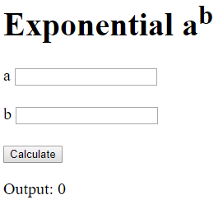

Let’s try to input numbers and click a button. Nothing happens.

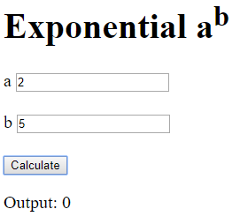

|  |
| --- |
| <!DOCTYPE html>  <html lang="en">  <head>  <meta charset="UTF-8">  <meta name="viewport" content="width=device-width, initial-scale=1.0">  <meta http-equiv="X-UA-Compatible" content="ie=edge">  <title>Debug</title>  </head>  <body>  <h1>Exponential a<sup>b</sup></h1>  a  <input type="number" id="txtBase"> <br><br>  b  <input type="number" id="txtIndex"> <br><br>  <button type="button">Calculate</button>  <p>Output: 0</p>  <script>  document.querySelector("button").onclick = power;  function power() {  let base = document.querySelector("#txtBase").value;  let index = document.querySelector("#txtIndex").value;    let result = 0;  for(let i=1; i<index; i++) {  result = result * base;  }  document.querySelector("p").innerHTML = "Output: " + result;  }  </script>  </body>  </html> |

Try to debug it by open “inspector”.

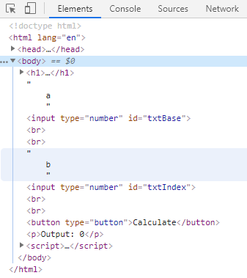

Press “ESC” to show another console.

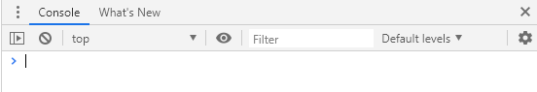

You can use a simple JS here. For example, type 1+2 and enter.

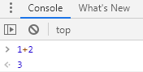

Let’s get the value from the first textbox.

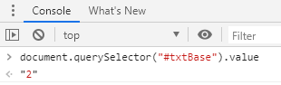

Observe that the return value is a text. It cannot be used for computing.

Try to convert it to number by testing this code.



There is another way to check the input value.

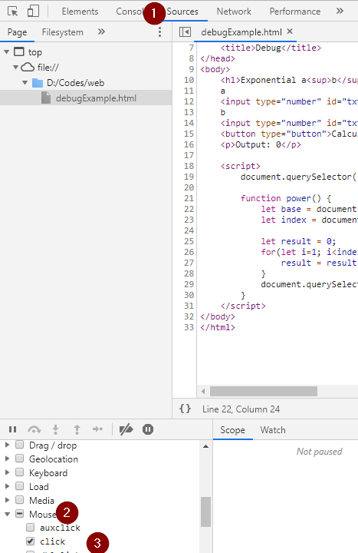

Now click the web button. Observe the pause at the function linked to the button.

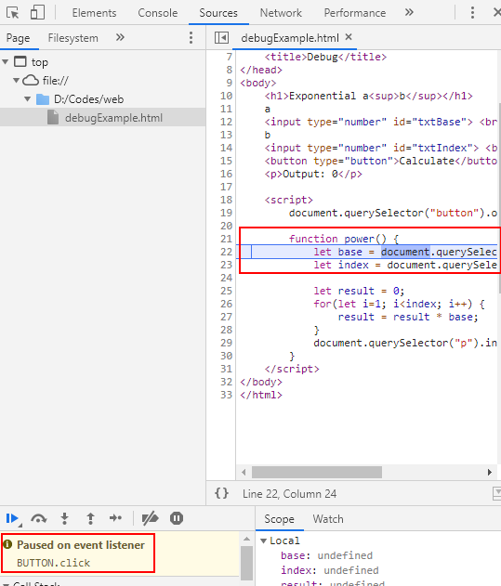

Click “step” or press F9.

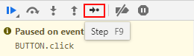

Observe that the program executes the next line and show the value of the previous line.

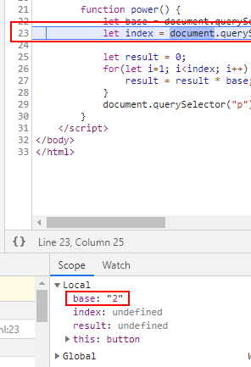

Press F9 again and see the next move.

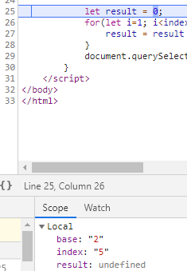

Now you see that both variables are text which are wrong.

Another debugging method is to add a breakpoint.

First uncheck the “click” mouse method.

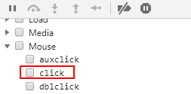

Then in source tab, click at the line as shown. This is called a breakpoint.

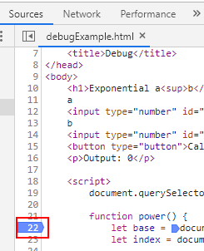

Then click the web button. The web stops at that line.

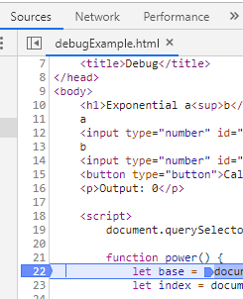

Again press F9 to move to the next line and see the variable value.

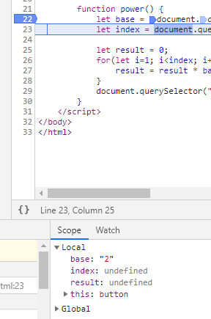

We can click the blue breakpoint to remove it.

Assume that now we correct the code to:

|  |
| --- |
| <!DOCTYPE html>  <html lang="en">  <head>  <meta charset="UTF-8">  <meta name="viewport" content="width=device-width, initial-scale=1.0">  <meta http-equiv="X-UA-Compatible" content="ie=edge">  <title>Debug</title>  </head>  <body>  <h1>Exponential a<sup>b</sup></h1>  a  <input type="number" id="txtBase"> <br><br>  b  <input type="number" id="txtIndex"> <br><br>  <button type="button">Calculate</button>  <p>Output: 0</p>  <script>  document.querySelector("button").onclick = power;  function power() {  let base = parseInt(document.querySelector("#txtBase").value);  let index = parseInt(document.querySelector("#txtIndex").value);    let result = 0;  for(let i=1; i<index; i++) {  result = result * base;  }  document.querySelector("p").innerHTML = "Output: " + result;  }  </script>  </body>  </html> |

Still the answer is 0 which is wrong.

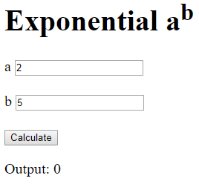

Let’s try to debug the process by adding a breakpoint.

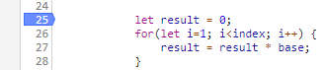

Then click a web button and then F9.

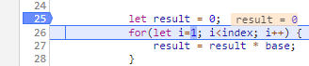

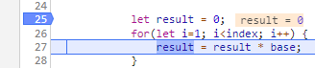

Move your mouse over the variable “base” and “result”.



Now we see the problem, the result variable is 0. When multiplying it with any number, you get 0.

Assume that you know the “result” should be 1. You can modify it directly in the console.

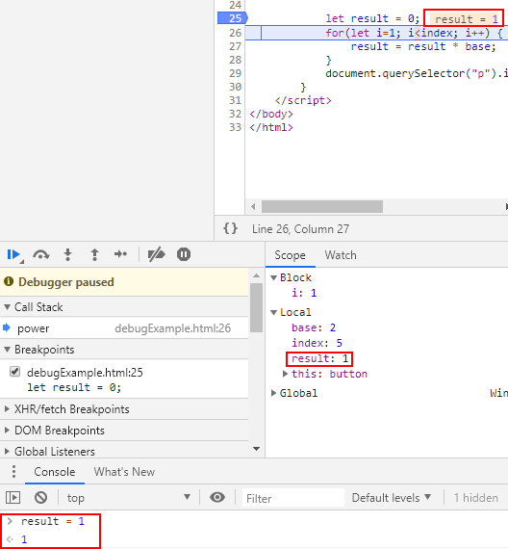

Then try to step forward for the next round of the loop. See that now result becomes 2.

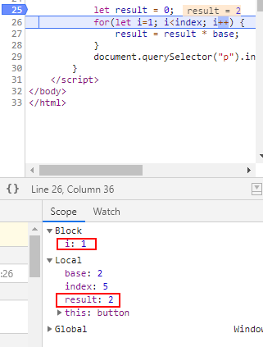

Try to press “Resume” or F8 to let all codes executed without breakpoint.

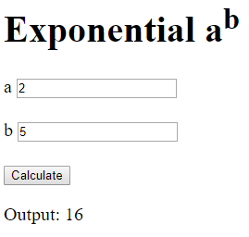

See that the output is incorrect. You know that it is due to the incorrect loop.

Correct all errors and get the new codes below.

|  |
| --- |
| <!DOCTYPE html>  <html lang="en">  <head>  <meta charset="UTF-8">  <meta name="viewport" content="width=device-width, initial-scale=1.0">  <meta http-equiv="X-UA-Compatible" content="ie=edge">  <title>Debug</title>  </head>  <body>  <h1>Exponential a<sup>b</sup></h1>  a  <input type="number" id="txtBase"> <br><br>  b  <input type="number" id="txtIndex"> <br><br>  <button type="button">Calculate</button>  <p>Output: 0</p>  <script>  document.querySelector("button").onclick = power;  function power() {  let base = parseInt(document.querySelector("#txtBase").value);  let index = parseInt(document.querySelector("#txtIndex").value);    let result = 1;  for(let i=1; i<=index; i++) {  result = result * base;  }  document.querySelector("p").innerHTML = "Output: " + result;  }  </script>  </body>  </html> |

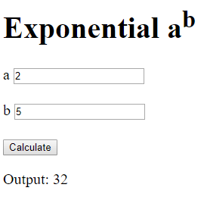

**Assignment 1** Modify the previous code to support a negative exponent.

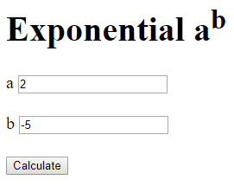

**Paste your code here.**

|  |
| --- |
| <!DOCTYPE html>  <html lang="en">  <head>  <meta charset="UTF-8">  <meta name="viewport" content="width=device-width, initial-scale=1.0">  <meta http-equiv="X-UA-Compatible" content="ie=edge">  <title>Wil-Week2-Assign 2</title>  </head>  <body>  <h1>Exponential a<sup>b</sup></h1>  a  <input type="text" id="txtA" > <br><br>  b  <input type="text" id="txtB"> <br><br>  <input type="button" value="Calculate" onclick="calculate()" >    <p>Output: 0</p>  <script>  function calculate() {  const a = parseFloat(document.getElementById("txtA").value);  const b = parseFloat(document.getElementById("txtB").value);  if(isNaN(a) || isNaN(b)){  alert("Input only Integer");  }else{  result = Math.pow(a,b);  }  document.querySelector("p").innerHTML = "Output = " + result;  }      </script>  </body>  </html> |

**Assignment 2** Coding the web survey as shown.

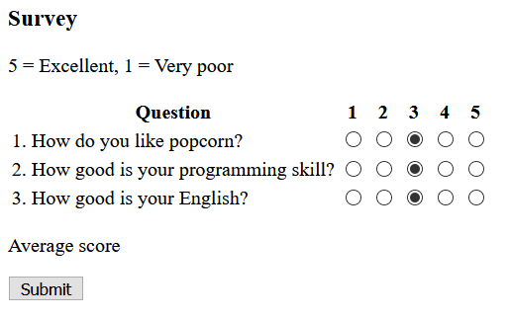

After clicking a button,

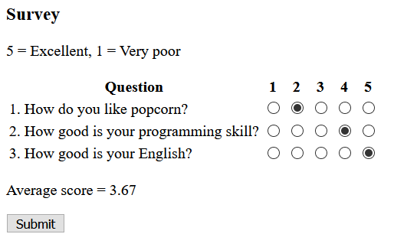

**Paste your code here.**

|  |
| --- |
| <!DOCTYPE html>  <html lang="en">  <head>  <meta charset="UTF-8">  <meta name="viewport" content="width=device-width, initial-scale=1.0">  <title>Document</title>  </head>  <body>  <h3>Survey</h3>  <p>5 = Excellent, 1 = Very poor</p>  &emsp; &emsp; &emsp; &emsp;&emsp; <strong>Question</strong> &emsp; &emsp; &emsp; &emsp; &emsp; &emsp;  1 2 3 4 5  <div>  1.How do you like popcorn? &emsp;&emsp;&emsp; &emsp;&emsp; <input type="radio" name="qt1" value="1"><input  type="radio" name="qt1" value="2"><input type="radio" name="qt1" value="3"><input type="radio"  name="qt1" value="4"><input type="radio" name="qt1" value="5"> <br>  2.How good is your programming skill?&emsp; <input type="radio" name="qt2" value="1"><input type="radio"  name="qt2" value="2"><input type="radio" name="qt2" value="3"><input type="radio" name="qt2"  value="4"><input type="radio" name="qt2" value="5"> <br>  3.How good is your English? &emsp;&emsp;&emsp;&emsp;&emsp;  <input type="radio" name="qt3" value="1"><input type="radio" name="qt3" value="2"><input type="radio"  name="qt3" value="3"><input type="radio" name="qt3" value="4"><input type="radio" name="qt3"  value="5">  <br>  <p id= "av">Average Score: </p>  <br>  <button type="button" onclick="getScore()">Submit</button>  </div>  <script>  function getScore() {  var qt1 = document.querySelector("input[name = 'qt1']:checked").value;  var qt11 = parseInt(qt1);  var qt2 = document.querySelector("input[name = 'qt2']:checked").value;  var qt22 = parseInt(qt2);  var qt3 = document.querySelector("input[name = 'qt3']:checked").value;  var qt33 = parseInt(qt3);  var result = (qt11 + qt22 + qt33) /3;  document.querySelector("#av").innerHTML = "Average Score: " + result;  }  </script>  </body>  </html> |